Module 2 – “Beyond Leadership” Seminar by Eric Worre
Presenters: Lauri Agner, NMD and Dawn Rathmann, NMD
“Foundation Rank”
“Power of Duplication”

The Foundational Rank position in our marketing plan if you duplicate it well, it will take you to the top.

Foundational =
Brick
Rank =

Maximizing and Duplicating
Sales Coordinator is the Key in this business.

The Value of the Fast Track Program:
a) Solid Foundation
b) Dual Focus
C) Clear Direction with a ________________________
D) Multiple aspect of emotional impact
E) Financial ___________________

A Rigid Start-Up System creates the best emotional experience for Preferred Customers and new Representatives.

How to Build Foundational Rank:
You must give clear Direction for a rigid start up system.
You must create a clear ________________for building our Foundational Rank.

The Path:
a) HLP Add PC’s + Team
b) 2000+ More PC’s + Team
c) Fast Track to SC - Keep filling the ______________________

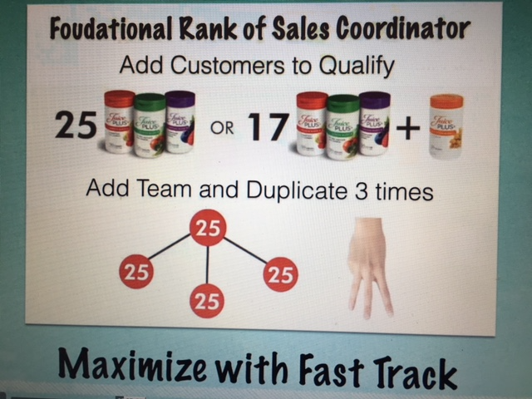

People DO what YOU _________, not what YOU _______________!

3 Guiding Principles for Duplication:
a) Clear __________________________
b) Create Emotional Connection/Impact
c) ___________________Rewards

Think of our business as a Primary Focus.

Duplication of the _________________________________position is Key!

Great Leaders start off as Great ________________________.

Path of Mastery:
a) Follow someone more successful than you.
b) Immerse yourself in the ____________________________they followed.
c) Practice with spaced ___________________________.
Plan Do Review

Keys for Emotional Connection/Impact:
a) Physiology and Posture
b) Language
c) Mental ______________

“Where focus goes ___________________flows.” Tony Robbins

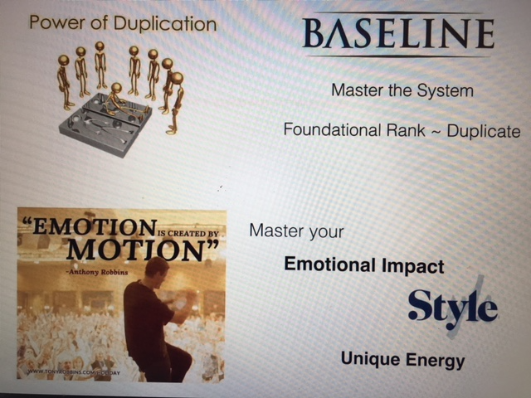

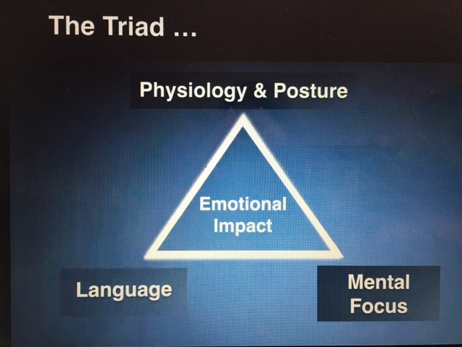

We reap Financial Rewards when we Fast Track to Sales Coordinator and teach our Reps to do the same.

In maximizing Financial Rewards………………….MORE MATTERS!

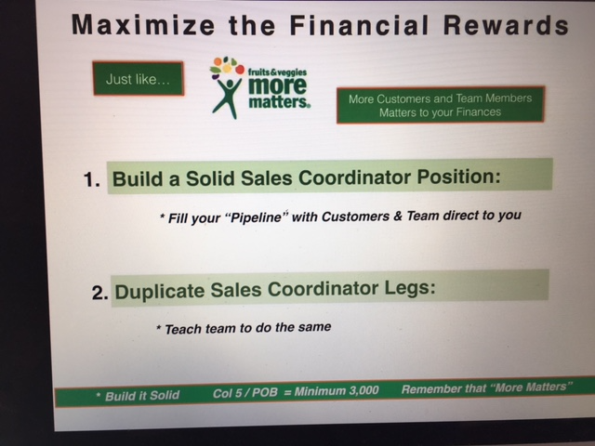
Fill your Pipeline with
Preferred Customers
and
Representatives
Direct to YOU!
Remember, Sales Coordinator is the BRICK, THE FOUNDATIONAL part of our marketing plan!

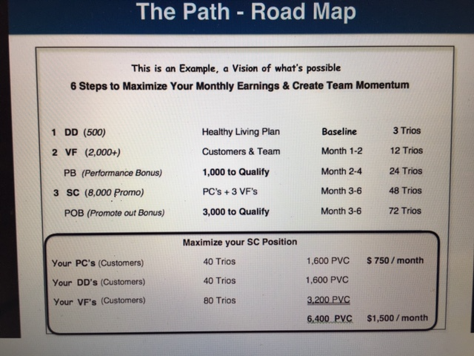

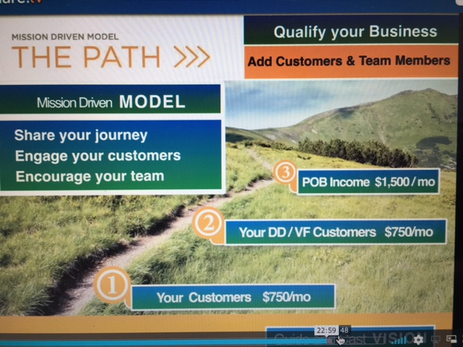
Our Mission Driven Model Is THE Path for Duplication!

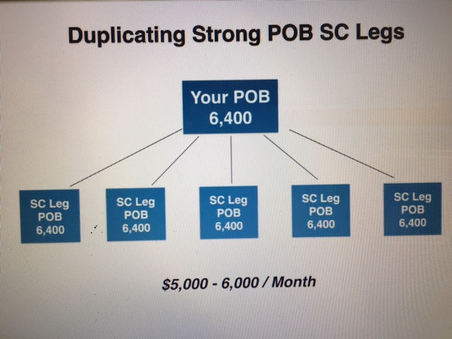

Duplication is Powerful!

Teaching to Teach to Teach
Is Essential for Long-Lasting
Duplication!

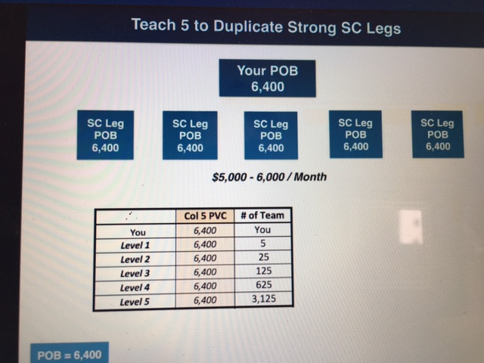
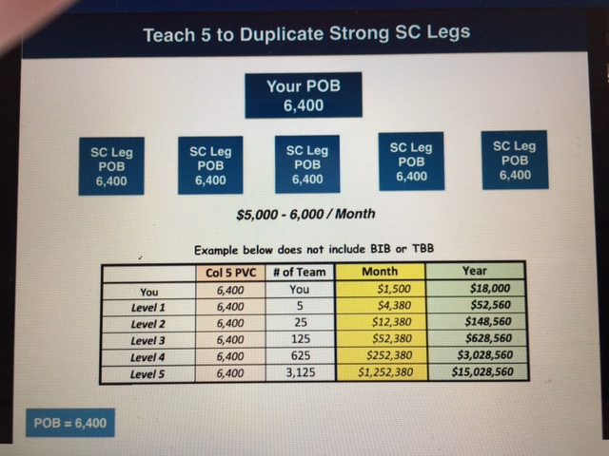

Even if we did 1/20th of the above, we’d be a millionaire!

Remember: When you attain Qualifying National Marketing Director and National Marketing Director, with the required structure and PB and POB volume, we get paid 5 levels deep.

People _______________________________what they can do in 1 year and __________________________what can happen in 3 years.

People do what you do so do it __________________!

“There will always be a good reason to ___________________.
And there will always be a good reason to _________________ __________________.
_____________________ what kind of person YOU are going to BE.” Eric Worre

Questions for Discussion and Action

1. Why is the Sales Coordinator position called the Foundational Rank in our marketing plan?
i.e. benefits and requirements

2. Where do you find where our Rigid Start-Up System is located?
What is our Rigid Start Up System for Preferred Customers?

What is our Rigid Start Up System for New Representatives?

3. Why is Duplication important in our business?

4. In order to become a great leader, you must first be a great follower. Why is this important?
Why don’t some Reps want to be great followers?
How do you know you have a great follower on your team?
What do great Leaders do to create and inspire great followers?

5. Describe the duplicable actions and tools we have to help a new Rep. attain SC.

6. Are you duplicable?
Why or why not?

7. Why do you feel your physiology, posture, language and mental focus are important
Emotional Connection and Impact? Give examples.

8. Is your Juice Plus+ business your Primary Focus?
If not, how can you make it so that it is?

9. How many frontline Sales Coordinators do you have on your team?

10. Who do you have in your pipeline to help attain SC?

11. More Matters! Do you have 1600 PVC from your Preferred Customers?
How much PVC comes from your PCs now? What do you need to reach 1600?
How many Trios (42.37 PVC installment plan) do you need?

12. Who can you work with to Fast Track to Sales Coordinator?
Write down 10 names now of whom you want to invite to look at our business.
Create a plan to contact them with your sponsor or NMD.

